RESUME

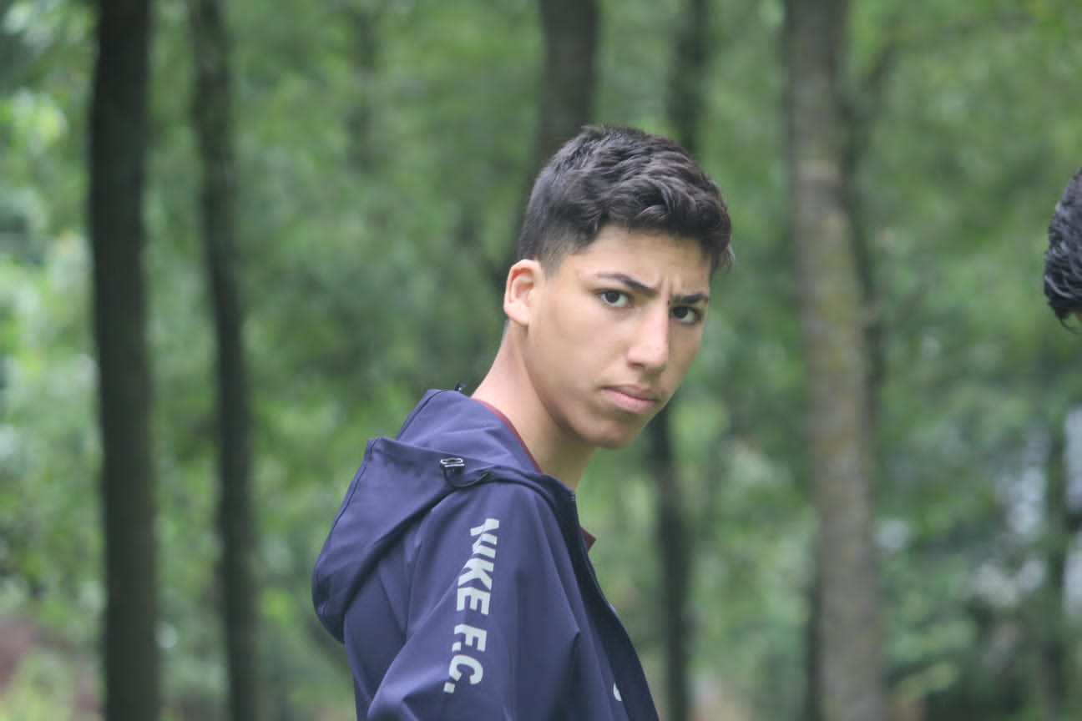
Mujtaba Alam Baba
Email: mujtabaalam010@gmail.com
Phone: +91-9797060239.
Address: Lessu Astanpora, Larnoo, Ananatnag, 192202, Jammu & Kashmir.
LinkedIn Profile: linkedin.com/in/mujtabaalam

Skills
• Web Development (HTML, CSS, JavaScript)
• Graphic designer in Canva and Figna
• UI/UX Design
• Team Collaboration and Leadership

Professional Experience
Web Developer Intern
• Developed responsive web applications using HTML, CSS, and JavaScript.
• Collaborated with the design team to enhance user experience.
• Debugged and optimized existing code to improve application performance.
Freelance Web Developer
January 2023 – Present
• Designed and developed websites for small businesses and entrepreneurs.
• Integrated APIs for dynamic content and enhanced functionalities.
• Provided ongoing technical support and maintenance.

Education
- Class 10th passed out from Davoodia Public School Gohan Vailoo.
- Currently studying in cass 11th.

Certifications
• Full-Stack Web Development Certification, Coursera – 2023
• JavaScript Advanced Concepts, Udemy – 2022•Freelancing and Social Media Management/Social Media Marketting from Influnce Kashmir

Projects
Artice website and secure payment gateway integration
Developed a frontend of an Article Website using HTML, CSS, JSON, and JavaScript
.Link: https://articleglobe.vercel.app/
Book store
Created a Fully functional Book website eith downloading functionality . Implemented using HTML, CSS, JSON, and JavaScript Link: https://md-books.vercel.app/
